Minutes of the Takeley Local History Society AGM

30th November 2004

The meeting was chaired by Steve Hazon and was reasonably well attended with 32 members in attendance and 6 visitors.

1. Minutes of the previous AGM
The minutes of the previous AGM held 4th November 2003 were accepted.

2. Society Activities for 2004
The current membership of the society stands at 60. Steve Hazon reviewed the activities of the society over the past year as follows:

Books
The following booklets have been published in the last year bringing the total number of publications to 10.

Mole Hill Green History Pat Salmon

In the Service of Their Country Bill Marshall
Takeley’s Service People of WWII Pat Salmon

Reads of Takeley Bill Marshall

Takeley Telephone Exchange Explosion Steve Hazon

Takeley Pubs Bill Marshall

Over 750 booklets have now been sold.

Work is in currently progress on additional chapter to the Servicemen book, and books on The School, The Street, Bambers Green, Smiths Green, and Crimes at Waltham Hall 1933/34 and Teagles in 1898.

Website and Email Contacts from the website
The website continues to be updated (many Takeley Wills have been added this year) and this acts as a shop window for the society to the rest of the world. 30 contacts by email have been made in the past year not including locals contacts with 527 emails in total. Many of these have been helped with genealogy enquiries by Pat Salmon.

Ongoing Projects
The following projects are ongoing.

Quarter Session Rolls - Nia and John Watkiss
Wills, several now on website - Nia and John Watkiss

A120 pics. - These were promised by Balfour Beaty on disk. We are now trying to get hold of the original photos.

Church – Large project to get all information about the church from records offices and collate it. Trevor Allen and Dave Venable.

Memorial Inscriptions – About an eight of the yard completed. Pat Salmon Phyllis Altham with help from others but more help needed in the spring.

Newspaper articles – Phyllis Altham collecting articles form the newspapers.

Old Newspapers - Pat Salmon looking at old papers in the archives.

Arial photos – still have a quarter of the village to do .Roy Livermore

School log books – database Dave Venable

Buildings database - Roy Livermore is working to produce a computer
database of interesting properties and places within the parish. He would like to be contacted by anyone living in a house that has some history with details which could be entered in the society's database.

Community Activities
Presentation of the Bound War Memorial book to the British Legion stored in the church 6th June 2004

Presentation of a set of TLHS publications to Takeley Primary School 21st June 2004

Presentations
24 February. Speaker: Martin Astell - The Essex Sound and Video Archive
20 April. Speaker: Nancy Woodley - The Cinderella Army. tales of the Land Army in WW2
22 June. Speaker: Mike Roy, Essex Archaeology Unit - Lower Bamber's Green Roman/Mediaeval Site
24 August. Guided tour of Holy Trinity Church by Trevor Allen
12 October. Speakers: Steve and Pat Schorah - Local Postcards
30 November. AGM. Speakers Trevor Allen - Slide show of Takeley Time Machine and Bill Marshall - Researching Information for the Booklets

3. Election of committee
Steve Hazon told the meeting that all current members of the society were ready to restand – however the society had been without a secretary for a year and desperately needed one.

Trevor Allen made an appeal for someone to stand as secretary but no-one came forward.

As a response to the request made in a letter to members Roy Whiteman volunteered to become Bookings Secretary and as such is elected to the committee along with all existing committee members who were re-elected unopposed.

4. Dates for next year
Steve Hazon told the meeting that the dates provisionally book with the school for meetings next year were:
1st February, 3rd May, 4th October and 29th November

5. Treasurers Report
The Treasurers Report by Phyllis Altham was circulated. Roy Whiteman questioned why the cash in hand remained the same in both the Income and Expenditure columns and Phyllis explained that this was because the only outgoings in the last year had been made as cheques not cash. Therefore the cash in hand remains the same.

Roy Whiteman proposed that the accounts be accepted, seconded by David Venable and unanimously carried by the members.

6. AOB
There being no other formal business the meeting continued with talks by Bill Marshall and Trevor Allen.

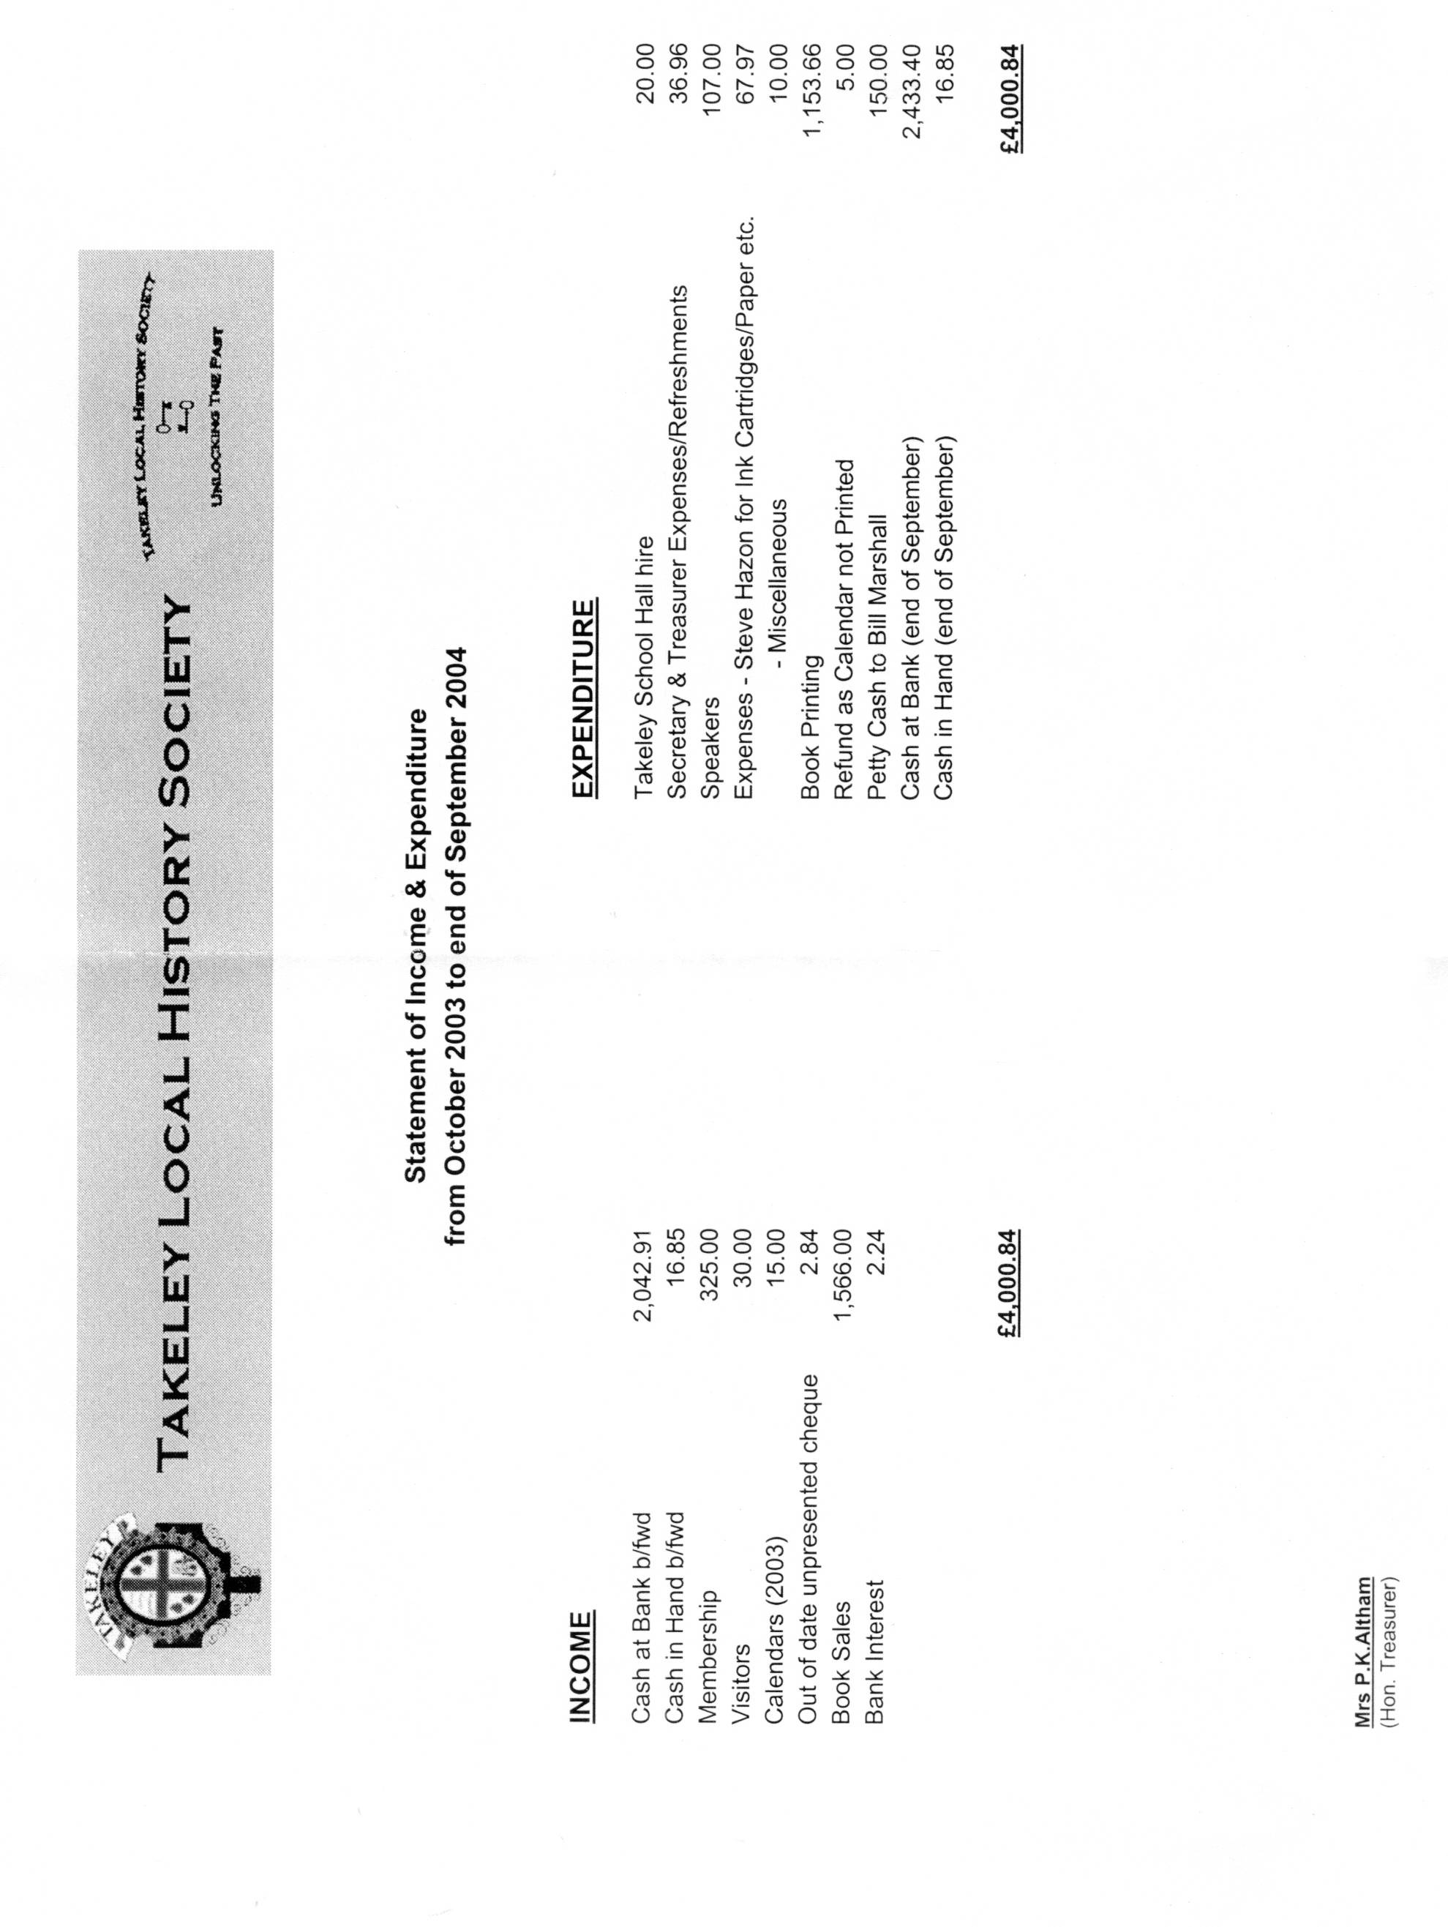
Treasurer’s Report

